Drivetrain:

Motors, Motor Controller, Omni-wheel, Drift of omni-wheels what we need to do to compensate

Possible solution for drift: Center Traction Wheel

Motor Controller: [Brushless DC Motor Drive Board 20A 12V-36V 500W DC Brushless Motor Controller](https://www.elecbee.com/en-31570-Brushless-DC-Motor-Drive-Board-20A-12V-36V-500W-DC-Brushless-Motor-Controller-With-Hall-Driver-Module?utm_term=&utm_campaign=shopping_%E7%BE%8E%E5%9B%BD2021/03/05&utm_source=adwords&utm_medium=ppc&hsa_acc=9958698819&hsa_cam=12473735731&hsa_grp=115457242501&hsa_ad=502747062194&hsa_src=g&hsa_tgt=pla-296303633664&hsa_kw=&hsa_mt=&hsa_net=adwords&hsa_ver=3&gad_source=1&gclid=CjwKCAiA5L2tBhBTEiwAdSxJXxcgB8f1DeZptPD32CSH0wr6QjyJdPgt0dOxpO8JdqHyzgYiwkL6bhoC2Y8QAvD_BwE)

<https://www.digikey.com/en/products/detail/infineon-technologies/BLDCSHIELDIFX007TTOBO1/10060562?utm_adgroup=&utm_source=google&utm_medium=cpc&utm_campaign=PMax%20Shopping_Product_Low%20ROAS%20Categories&utm_term=&utm_content=&utm_id=go_cmp-20243063506_adg-_ad-__dev-c_ext-_prd-10060562_sig-CjwKCAiA5L2tBhBTEiwAdSxJX4Gt7e9CyeFIYgYLg5OVaM7RczaOP3Mjt-dKT74zXUJQh-SP-xtqThoCt9EQAvD_BwE&gad_source=1&gclid=CjwKCAiA5L2tBhBTEiwAdSxJX4Gt7e9CyeFIYgYLg5OVaM7RczaOP3Mjt-dKT74zXUJQh-SP-xtqThoCt9EQAvD_BwE>

Motors:

Omniwheel:

Computer Vision:

Install OpenCV library on RaspberryPi and use pre-trained models for person detection. Connect RaspberryPi to the main processor (STM32?) via protocols.

Bluetooth tracking/UWB/Time of Flight tracking:

[Qorvo RF Modules based on Decawave's DW1000 Ultra Wideband (UWB) transceiver IC](https://www.mouser.com/ProductDetail/Qorvo/DWM1000?qs=TiOZkKH1s2R6b5D6df63Pg%3D%3D)

[Insight SiP ISP3010 Smart Ultra-Wide Band BLE 5 Module](https://www.mouser.com/new/insight-sip/insight-sip-isp3010-uwb-ble-module/)

[DW1000 - 3.5 - 6.5 GHz Ultra-Wideband (UWB) Transceiver IC with 1 Antenna Port](https://www.qorvo.com/products/p/DW1000)

*We can think of designing our PCB as a raspberry pi HAT to handle vision processing

Bluetooth Tracking: <https://www.lairdconnect.com/resources/blog/magic-bluetooth-aoaaod-direction-finding#:~:text=With%20Angle%20of%20Departure%20measurement,called%20IQ%20sample%20data)%20the>

​​

<https://www.bluetooth.com/learn-about-bluetooth/feature-enhancements/direction-finding/>

[Bluetooth Vs. UWB](https://www.blueiot.com/bluetooth-aoa-vs-uwb.html)

UWB vs. Bluetooth vs. Chirp vs. Wi-Fi

<https://www.inpixon.com/technology/standards/ultra-wideband>

[Oxygen tank reference info](https://www.megamedical.com.au/oxygen-cylinder-capacity-understanding-different-sizes-and-their-uses/)

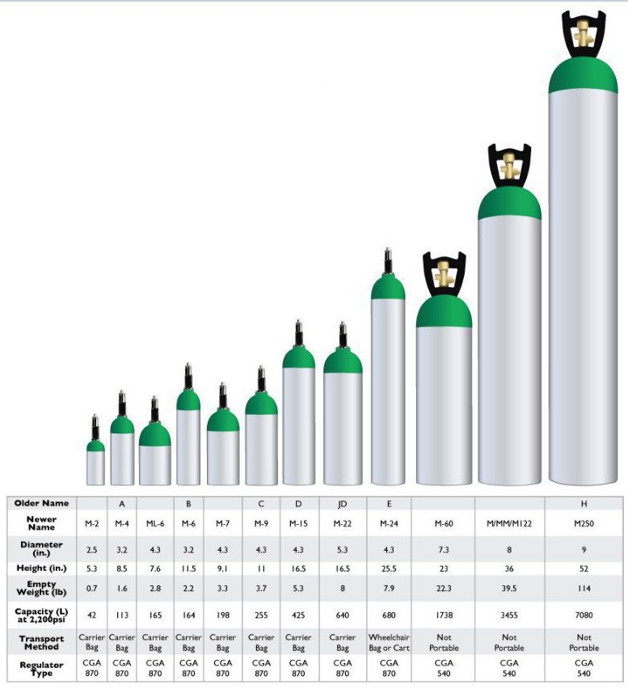

# Oxygen Delivery Robot

Team Members:

- Rutvik Sayankar (rutviks2)

- Aidan Dunican (dunican2)

- Nazar Kalyniouk (nazark2)

# Problem

Children's interstitial and diffuse lung disease (ChILD) is a collection of diseases or disorders. These diseases cause a thickening of the interstitium (the tissue that extends throughout the lungs) due to scarring, inflammation, or fluid buildup. This eventually affects a patient’s ability to breathe and distribute enough oxygen to the blood.

Numerous children experience the impact of this situation, requiring supplemental oxygen for their daily activities. It hampers the mobility and freedom of young infants, diminishing their growth and confidence. Moreover, parents face an increased burden, not only caring for their child but also having to be directly involved in managing the oxygen tank as their child moves around.

# Solution

Given the absence of relevant solutions in the current market, our project aims to ease the challenges faced by parents and provide the freedom for young children to explore their surroundings. As a proof of concept for an affordable solution, we propose a three-wheeled omnidirectional mobile robot capable of supporting filled oxygen tanks in the size range of M-2 to M-9, weighing 1 - 6kg (2.2 - 13.2 lbs) respectively (when full). Due to time constraints in the class and the objective to demonstrate the feasibility of a low-cost device, we plan to construct a robot at a ~50% scale of the proposed solution. Consequently, our robot will handle simulated weights/tanks with weights ranging from 0.5 - 3 kg (1.1 - 6.6 lbs).

The robot will have a three-wheeled omni-wheel drive train, incorporating two localization subsystems to ensure redundancy and enhance child safety. The first subsystem focuses on the drivetrain and chassis of the robot, while the second subsystem utilizes ultra-wideband (UWB) transceivers for triangulating the child's location relative to the robot in indoor environments. As for the final subsystem, we intend to use a camera connected to a Raspberry Pi and leverage OpenCV to improve directional accuracy in tracking the child.

As part of the design, we intend to create a PCB in the form of a Raspberry Pi hat, facilitating convenient access to information generated by our computer vision system. The PCB will incorporate essential components for motor control, with an STM microcontroller serving as the project's central processing unit. This microcontroller will manage the drivetrain, analyze UWB localization data, and execute corresponding actions based on the information obtained.

# Solution Components

## Subsystem 1: Drivetrain and Chassis

This subsystem encompasses the drive train for the 3 omni-wheel robot, featuring the use of 3 H-Bridges (L298N - each IC has two H-bridges therefore we plan to incorporate all the hardware such that we may switch to a 4 omni-wheel based drive train if need be) and 3 AndyMark 245 RPM 12V Gearmotors equipped with 2 Channel Encoders. The microcontroller will control the H-bridges. The 3 omni-wheel drive system facilitates zero-degree turning, simplifying the robot's design and reducing costs by minimizing the number of wheels. An omni-wheel is characterized by outer rollers that spin freely about axes in the plane of the wheel, enabling sideways sliding while the wheel propels forward or backward without slip. Alongside the drivetrain, the chassis will incorporate 3 HC-SR04 Ultrasonic sensors (or three bumper-style limit switches - like a Roomba), providing a redundant system to detect potential obstacles in the robot's path.

## Subsystem 2: UWB Localization

This subsystem suggests implementing a module based on the DW1000 Ultra-Wideband (UWB) transceiver IC, similar to the technology found in Apple AirTags. We opt for UWB over Bluetooth due to its significantly superior accuracy, attributed to UWB's precise distance-based approach using time-of-flight (ToF) rather than meer signal strength as in Bluetooth.

This project will require three transceiver ICs, with two acting as "anchors" fixed on the robot. The distance to the third transceiver (referred to as the "tag") will always be calculated relative to the anchors. With the transceivers we are currently considering, at full transmit power, they have to be at least 18" apart to report the range. At minimum power, they work when they are at least 10 inches. For the "tag," we plan to create a compact PCB containing the transceiver, a small coin battery, and other essential components to ensure proper transceiver operation. This device can be attached to a child's shirt using Velcro.

## Subsystem 3: Computer Vision

This subsystem involves using the OpenCV library on a Raspberry Pi equipped with a camera. By employing pre-trained models, we aim to enhance the reliability and directional accuracy of tracking a young child. The plan is to perform all camera-related processing on the Raspberry Pi and subsequently translate the information into a directional command for the robot if necessary. Given that most common STM chips feature I2C buses, we plan to communicate between the Raspberry Pi and our microcontroller through this bus.

## Division of Work:

Given that we already have a 3 omni wheel robot, it is a little bit smaller than our 50% scale but it allows us to immediately begin work on UWB localization and computer vision until a new iteration can be made. Simultaneously, we'll reconfigure the drive train to ensure compatibility with the additional systems we plan to implement, and the ability to move the desired weight. To streamline the process, we'll allocate specific tasks to individual group members – one focusing on UWB, another on Computer Vision, and the third on the drivetrain. This division of work will allow parallel progress on the different aspects of the project.

# Criterion For Success

* Omni-wheel drivetrain that can drive in a specified direction.
* Close-range object detection system working (can detect objects inside the path of travel).
* UWB Localization down to an accuracy of < 1m.

## Current considerations

We are currently in discussion with Greg at the machine shop about switching to a four-wheeled omni-wheel drivetrain due to the increased weight capacity and integrity of the chassis. To address the safety concerns of this particular project, we are planning to implement the following safety measures:

- Limit robot max speed to <5 MPH

- Using Empty Tanks/ simulated weights. At NO point ever will we be working with compressed oxygen. Our goal is just to prove that we can build a robot that can follow a small human.

- We are planning to work extensively to design the base of the robot to be bottom-heavy & wide to prevent the tipping hazard.

Small tank: 11” height, 3” diameter

Big Tank: 13” height, 5” diameter,

Titos: ~11”

Real world heights, should roughly be scaled up 1.3”